CSE301 Biocomputation, 2016
Elman Networks

Q1. Describe the architecture and the computational task of the NetTalk neural network.

Answer: architecture:
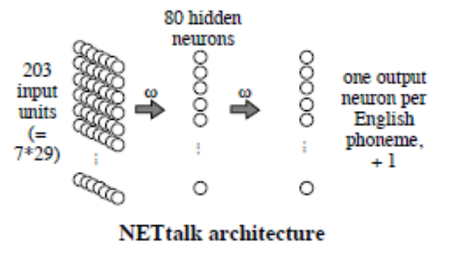
Each group of 29 input units represents a letter, so inputs together represent seven letters.
Right-hand caption should say “one output per English phoneme +2” (not + 1).
The computational task is to output the representation of the phoneme corresponding to the middle letter of the seven

Q2 .Why does a time-delay neural network (TDNN) have the same set of incoming weights for each column of hidden units?

Answer:
To provide temporal translation invariance. Or
So that the TDNN will be able to identify the input sound, no matter which frame the input sound begins in.

Q3. Distinguish between a feedforward network and a recurrent network.

Answer:
A feedforward network has no cyclic activation flows.

Q4 Draw a diagram illustrating the architecture of Elman’s simple recurrent network that performs a temporal version of the XOR task. How are the two inputs to XOR provided to this network?

Answer:
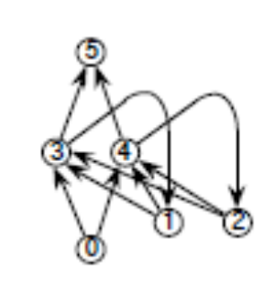
The inputs are passed sequentially to the single input unit (0) of the temporal XOR net.

Q5. Briefly describe the use of cluster analysis in Elman’s lexical class discovery experiments, and one of his conclusions from this.

Answer:
Elman clustered hidden unit activation patterns corresponding to different input vectors and different sequences of input units. He found that the clusters corresponded well to the grammatical contexts in which the inputs (or input sequences) occurred, and thus concluded that the network had in effect learned the grammar.

